**Mentorship program – Attendance Analysis**

This Document shows the analysis report of the student attendance details of the Mentorship Program. The details of the input file are as follows:

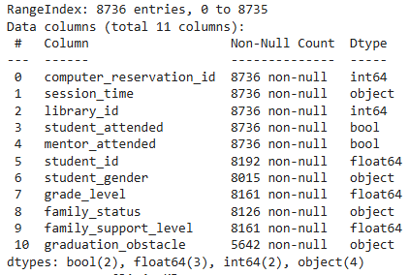

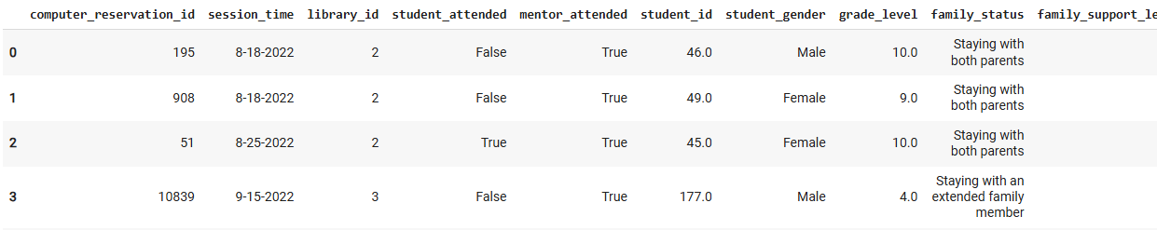

**Analysis:**

***Gender and Mentor attendance:***

* Gender does not influence the student’s attendance.
* Though it is obvious that student attendance and mentor attendance have some correlation, a significant number of students were present when mentors were absent.

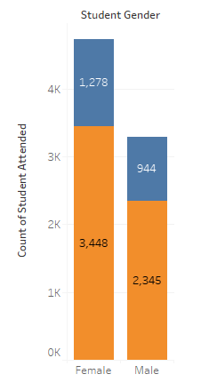 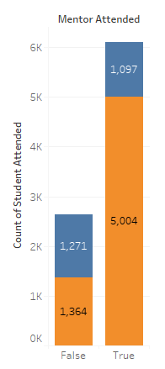 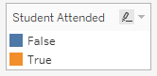

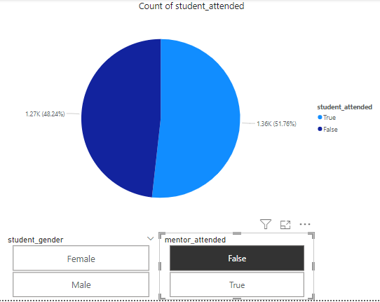

***Graduation Obstacle:***

* Financial is the main obstacle for both genders.
* Peer influence is a major obstacle for males while parenting doesn’t count.

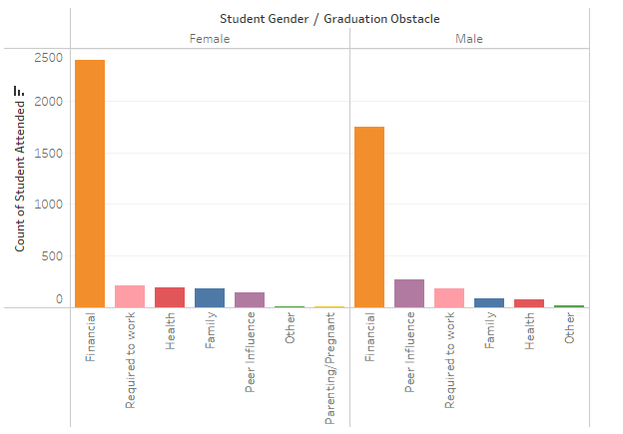

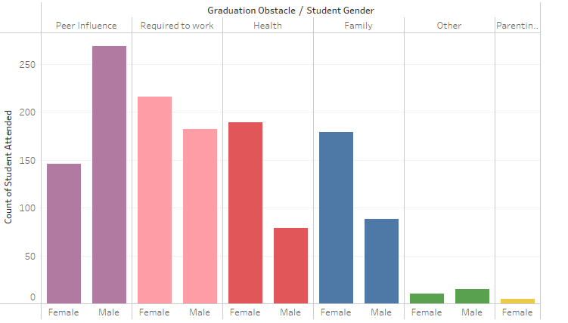

***Date/Day of Week:***

* From the Day of the week, Sunday recorded the lowest attendance and Saturday the highest among female students.
* Friday and Sunday recorded the lowest attendance and Thursday the highest among Male students.

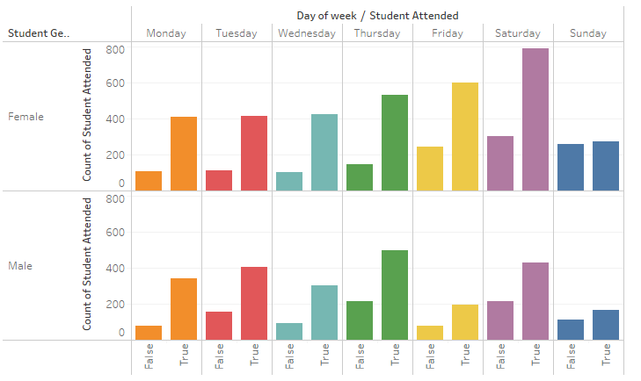

***Family Status:***

* The attendance/student_attended percentage is high among students with the family status of ‘Staying with both parents’.

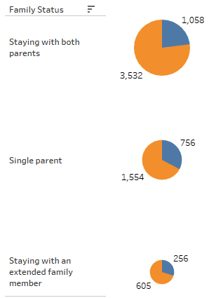

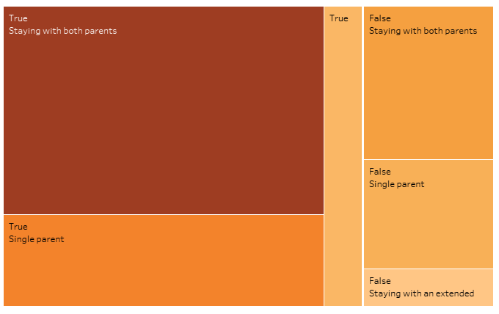

***Family Support level:***

* Attendance percentage is high among the students with a ‘Family Support Level’ of 2.

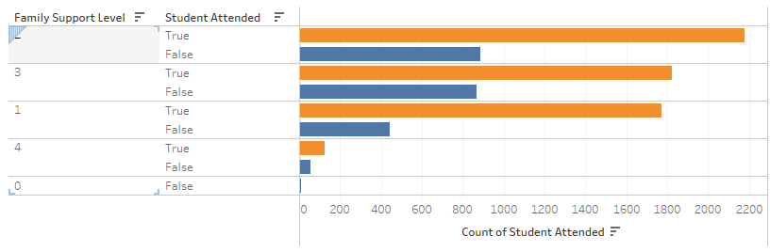

***Grade:***

* From the graph, the attendance percentage is high among the Elementary 5th-grade students.
* The absent percentage is high among the 7th and 6th grade middle schoolers.

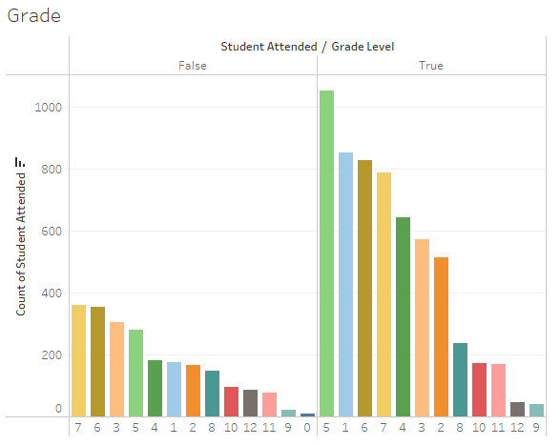

***Library Id:***

* The absent percentage is very high in the Library ID – 8 and the attendance/student_attended percentage is high in the Library ID – 6.

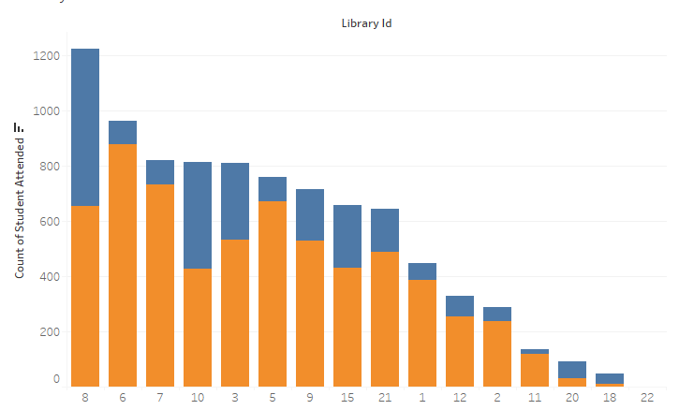

***Correlation:***

* Correlation between ‘student_attended' and other columns in the table.

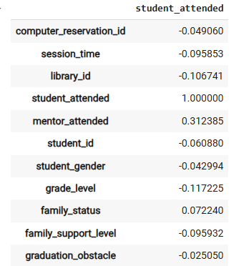

**Conclusion:**

Although there is no explicit and significant correlation between the student’s attendance and other factors from the table, some factors like the Day of the week, Family support/status, Grade, and Library ID play a role in the student’s attendance.